A postdoctoral researcher in land use change modelling for climate change mitigation
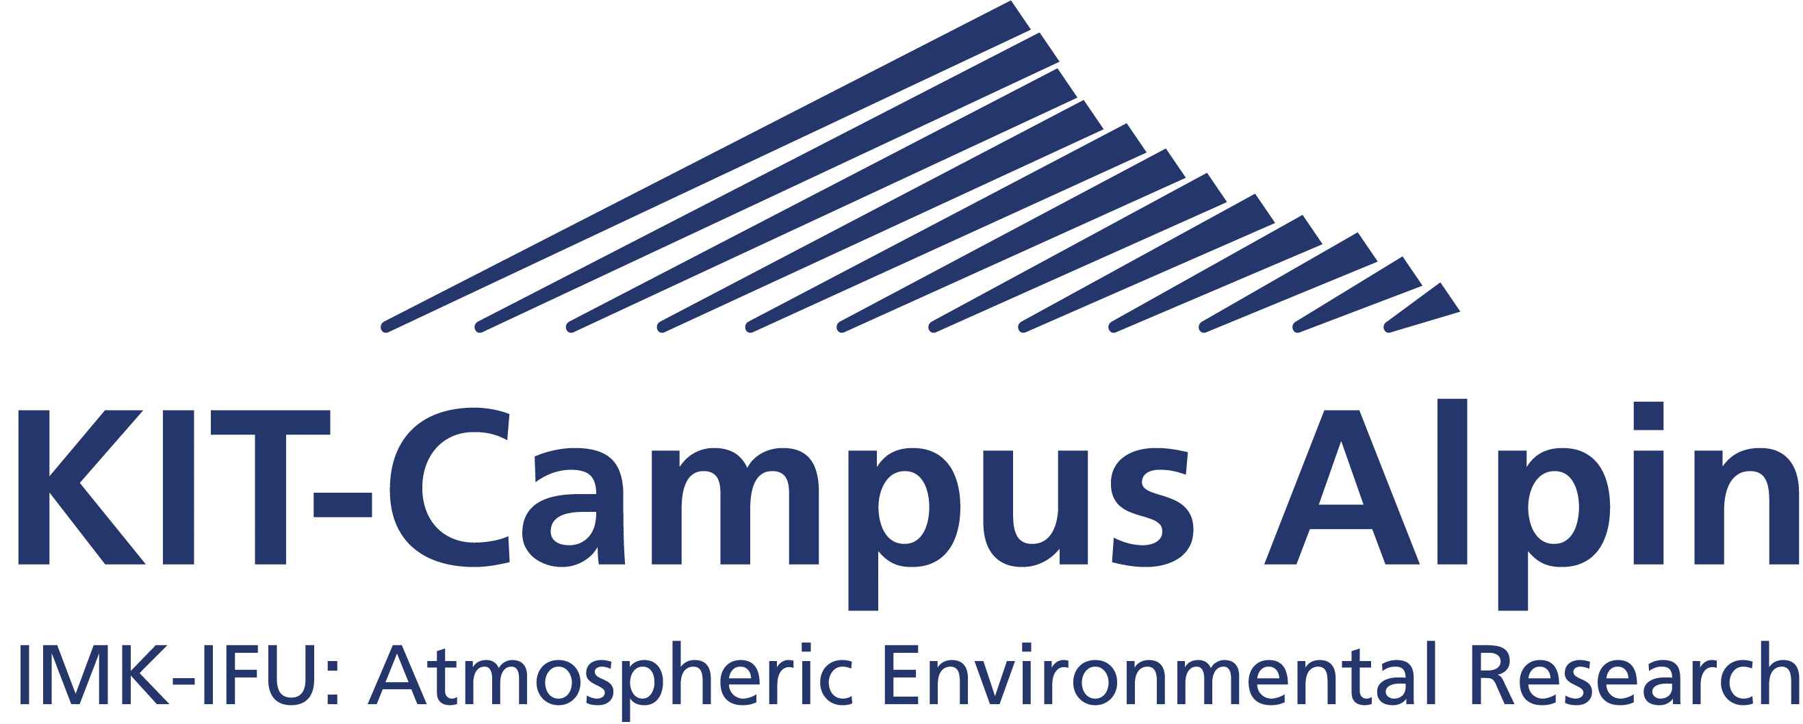
Institute of Meteorology and Climate Research
Atmospheric Environmental Research (IMK-IFU)
Kreuzeckbahnstr. 19
82467 Garmisch-Partenkirchen, Germany

Karlsruhe Institute of Technology, Campus Alpin (IMK-IFU), Garmisch-Partenkirchen, Germany

Overview
We are seeking a postdoctoral researcher in the field of land use change modelling to analyse the potential for land-based, climate change mitigation. The position will be held within the Land Use Change & Climate Research Group (https://landchange.imk-ifu.kit.edu/) of the Karlsruhe Institute of Technology (KIT), located at KIT’s ‘Campus Alpin’ in Garmisch-Partenkirchen, Germany. Specifically, we seek to employ a land use modeller to develop and apply the CRAFTY agent-based model of land use change (see: https://landchange.imk-ifu.kit.edu/CRAFTY) in evaluating land-based, climate change mitigation scenarios and policy options at the national scale in Germany.
Your specific roles will be to contribute to the further development, application and testing of the CRAFTY model, and to contribute to its coupling with the LPJ-GUESS vegetation model. The position will also involve some contributions to teaching and group administration. The position is available from 1 November 2021 for 2 years (subject to confirmation of project funding) with the potential for extension by a further year. The position holder will be located at KIT’s attractive Alpine Campus in Garmisch-Partenkirchen, Germany. Salary will be equivalent to the public service TV-L EG13, depending on qualifications and experience.

Qualifications
You will have a PhD degree in a relevant discipline and strong quantitative skills in computer modelling and the analysis of large-scale datasets in the environmental sciences (GIS experience alone is insufficient). Experience with statistical analysis, scenario analysis, ecological economics, ecosystem modelling, computational social sciences or computer programming is desirable. You will need to have proficiency in the English language, both spoken and in writing and preferably a working knowledge of German. Further information can be obtained from Prof. Mark Rounsevell (mark.rounsevell@kit.edu) or Dr. Calum Brown (calum.brown@kit.edu).

Applications
Applications should be sent by email to Sylvia Kratz (sylvia.kratz@kit.edu) by the extended deadline of Friday 8 October 2021, quoting the relevant reference, CRAFTY-DE. Applications should be submitted within a single PDF document that includes your CV, publications list (with citations), a short (1-2 page) letter of motivation and contact details for 2 referees. The motivation letter should clearly state how your research interests relate to the job specifications provided above. Applications that are incomplete or do not address these criteria will not be considered.
Interviews will be held remotely on Monday 18 October 2021.
KIT strives to achieve gender balance at all levels of employment. We therefore particularly encourage female candidates to apply for this position. With appropriate qualifications, applications from persons with handicaps are treated preferentially.

